**MASTER Procedure and Help Manual**

Written by Zachary Jacobson

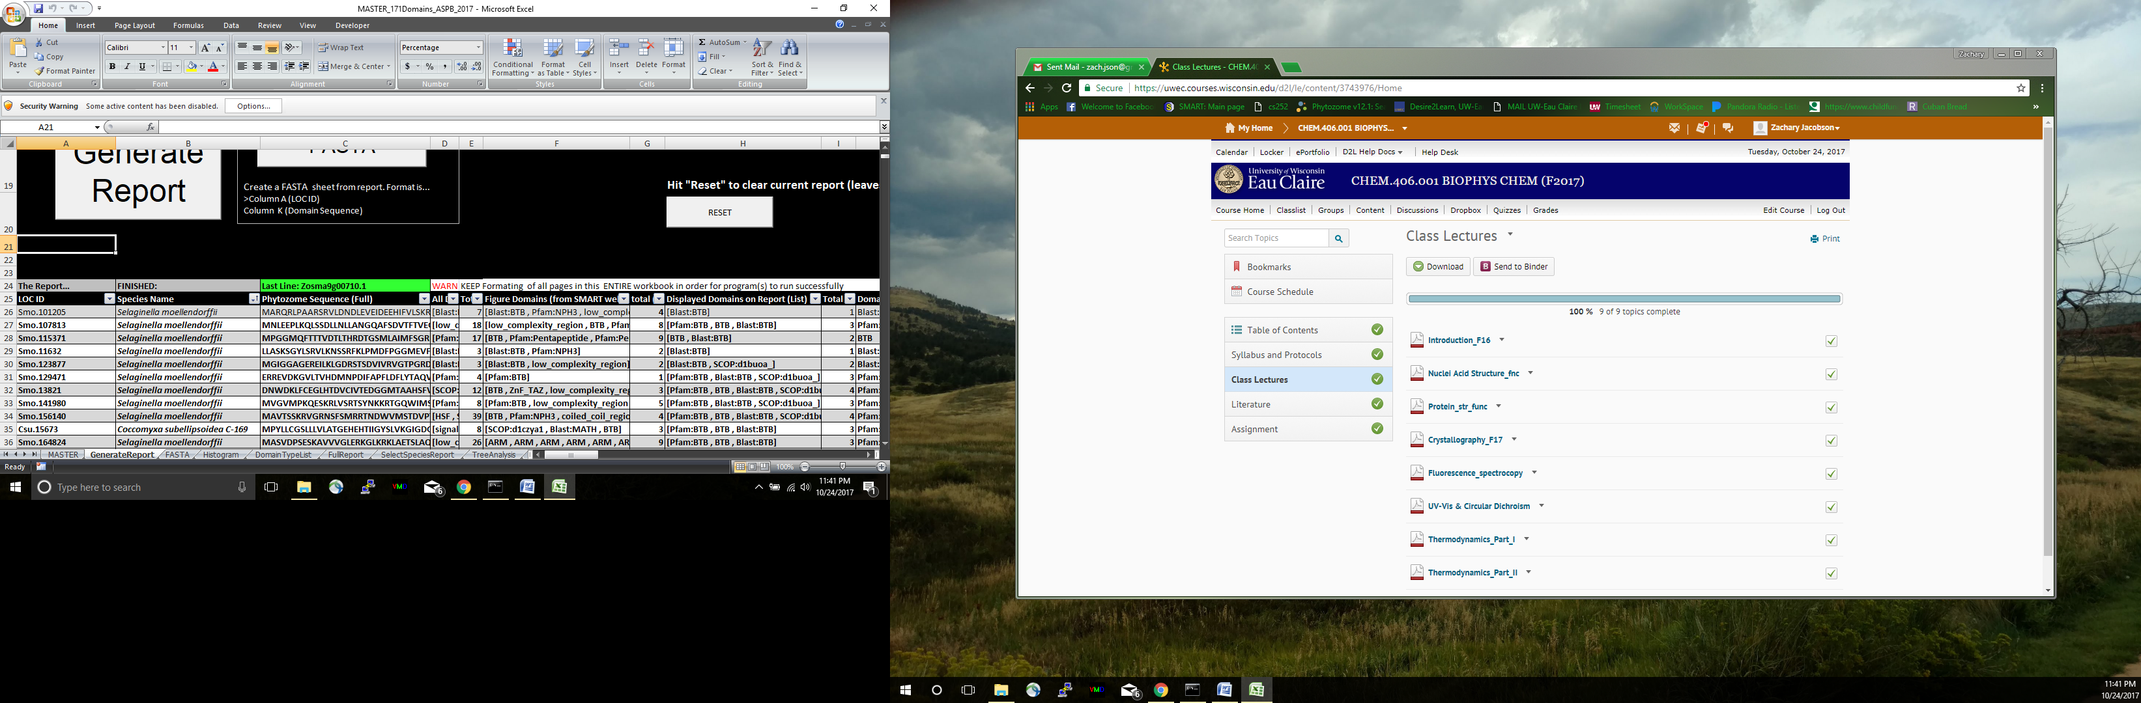 Start by opening the spread sheet in excel, you may need to select “Options”…

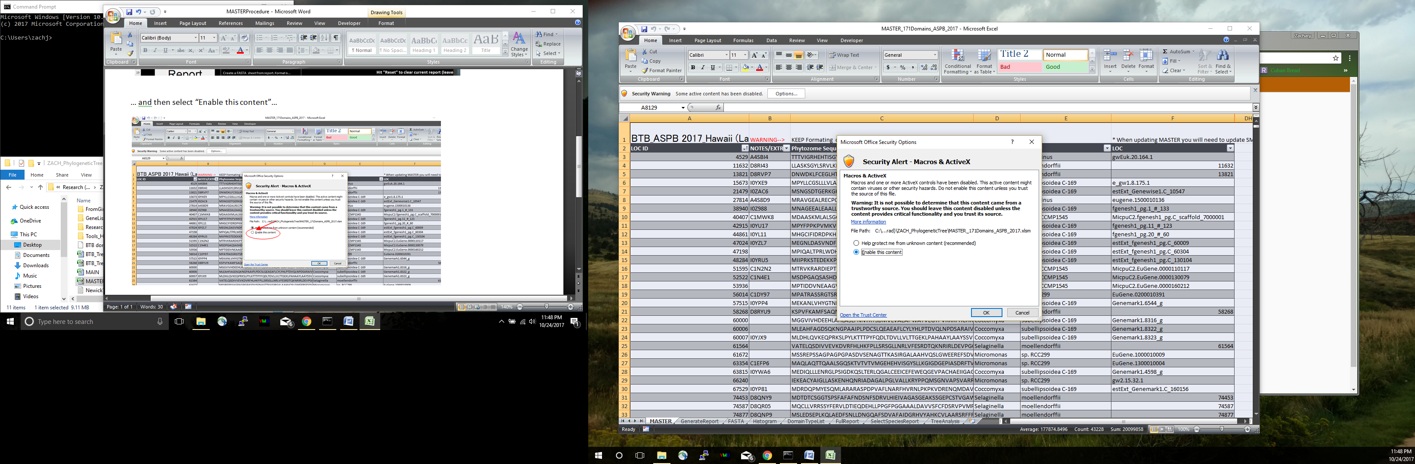… and then select “Enable this content” and hit “OK”…

The above steps may need to be done every time you re-open the spread sheets

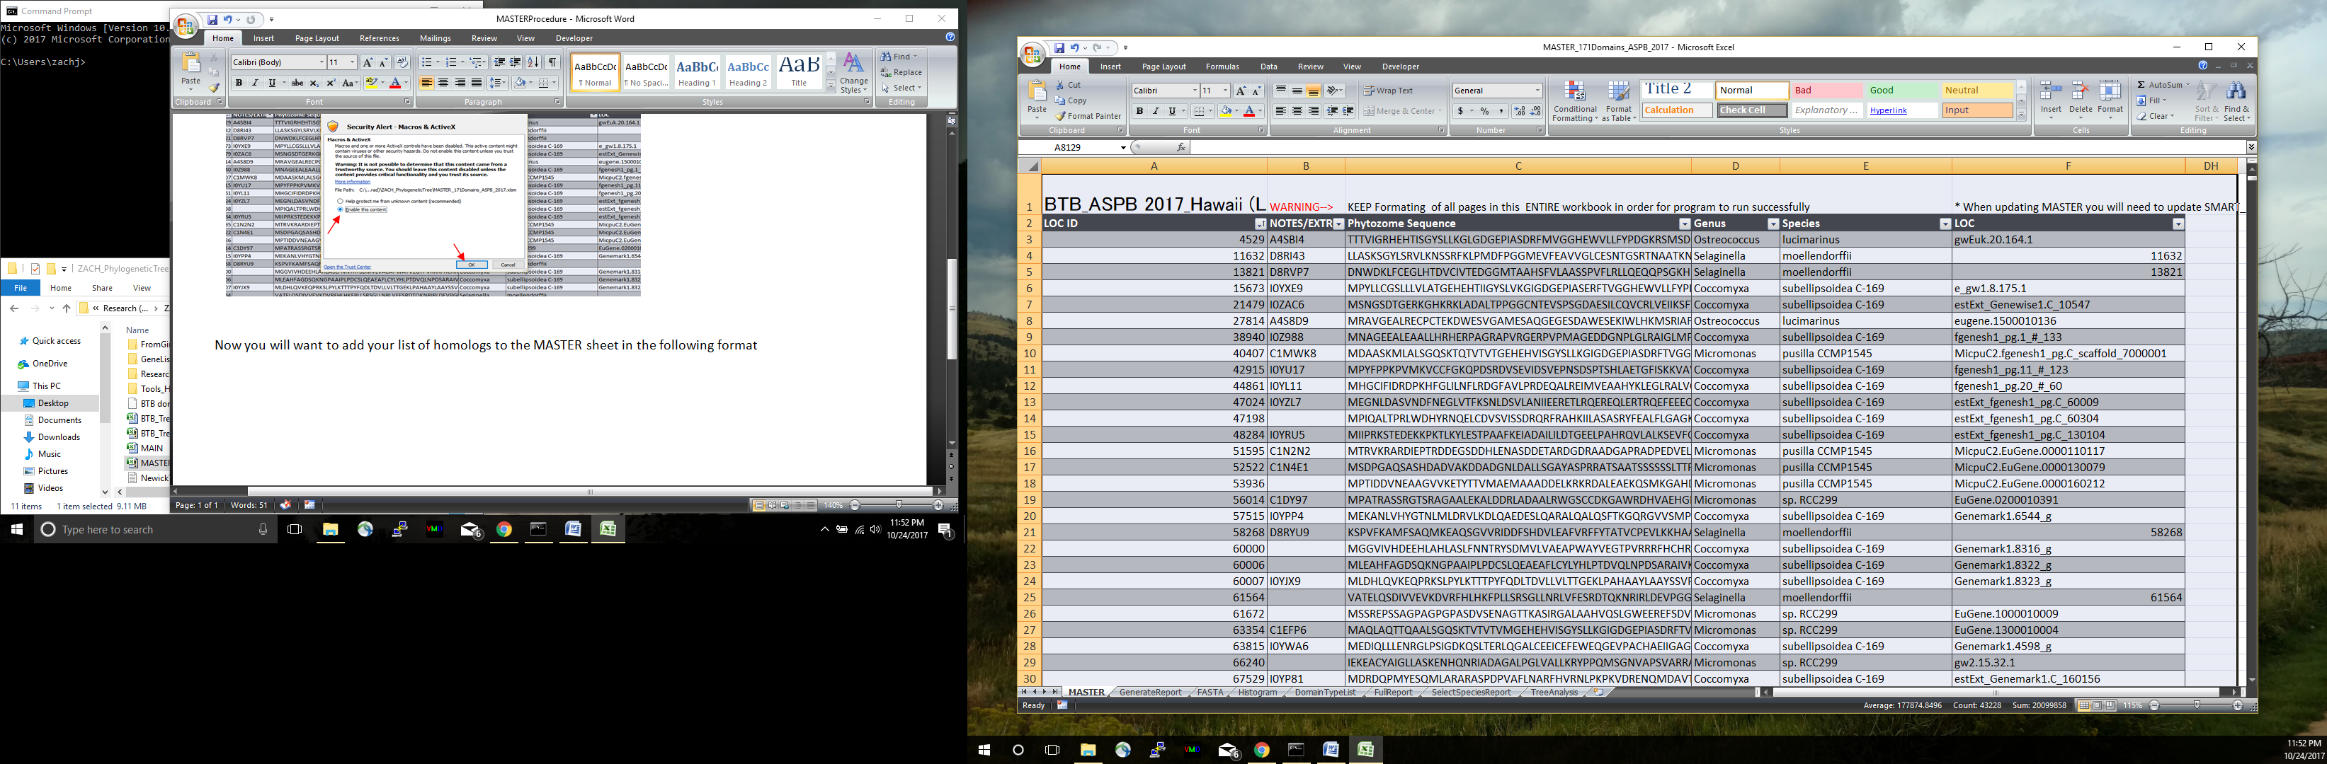Now you will want to add your list of homologs to the MASTER sheet in the following format…

*FORMAT IS IMPORTANT. I hard coded the column and start row numbers the program pulls information from. If this were to be improved one should transfer data to MySQL or Oracle compatible tables.

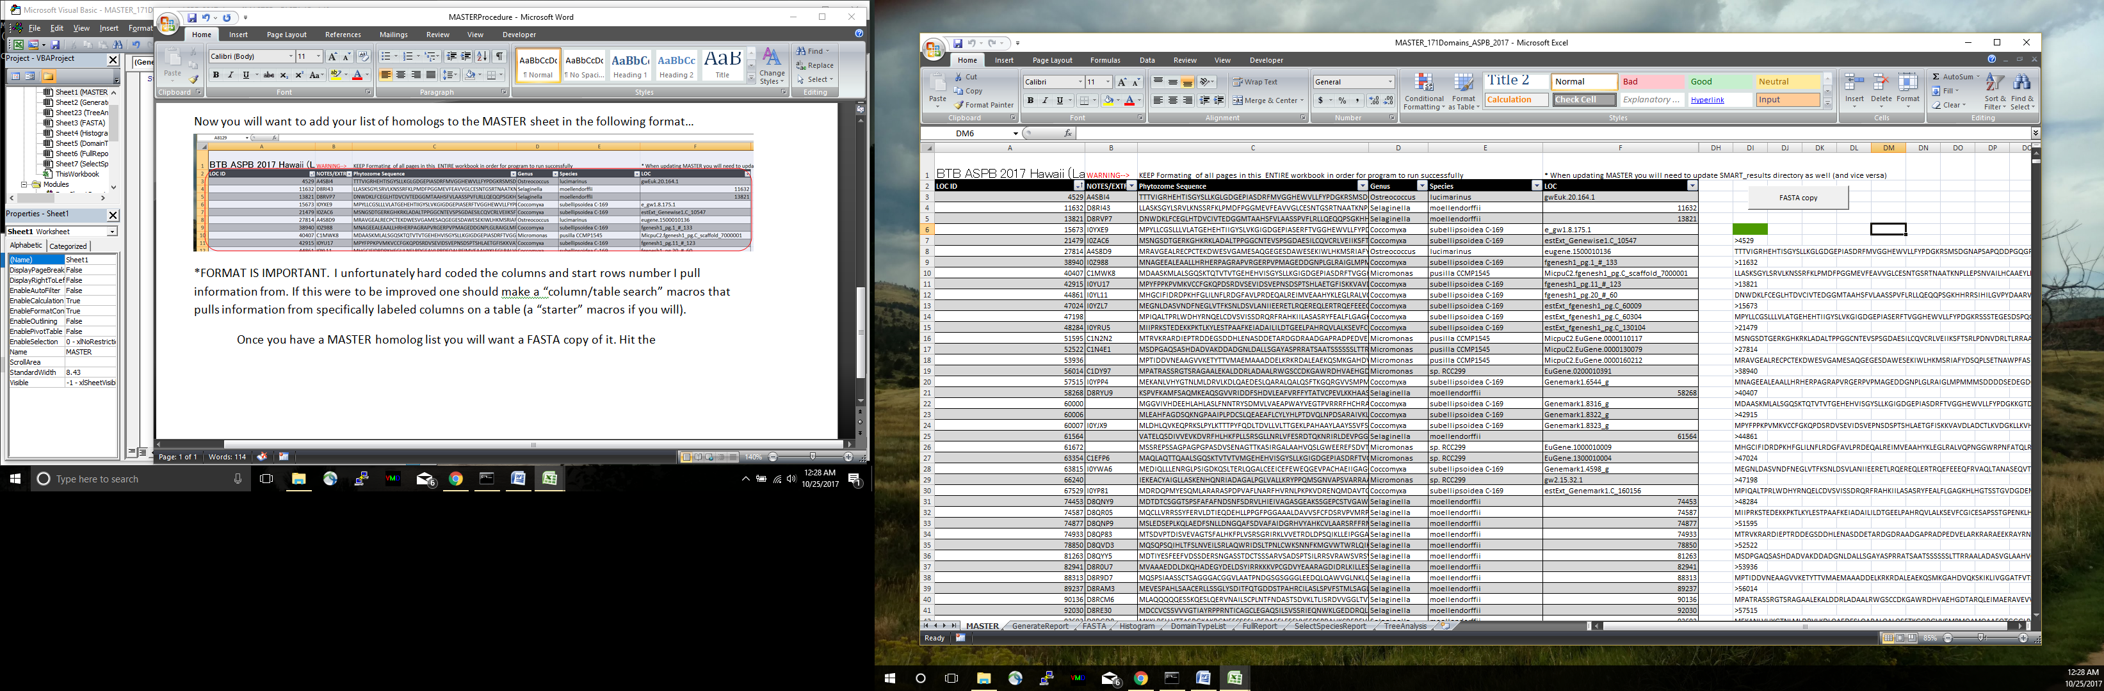Once you have a MASTER homolog table you will want a FASTA copy of it. Hit the “FASTA copy” button to the left of the MASTER homolog table…

Now it is time to make a SMART_results directory (folder) that contains all the resulting domain searches of every homolog sequence in your MASTER table. *THIS WILL TAKE SOME TIME (it took 3+ days of automated searches to get a completed directory for over ~8,500 searched sequences). Start by copy and pasting the FASTA formatted homologs into a .txt file which can be labeled any way you would like, but for simplicities sake I will refer to as FASTA_batch.txt in these instructions. These next set of instructions will be a combination of “one-time” computer set-up instructions and “SMART_batch.pl” command prompt help.

**Command Prompt Beginners Guide**

-search “cmd” in the “Search Windows” box in the bottom left corner and open “Command Prompt”

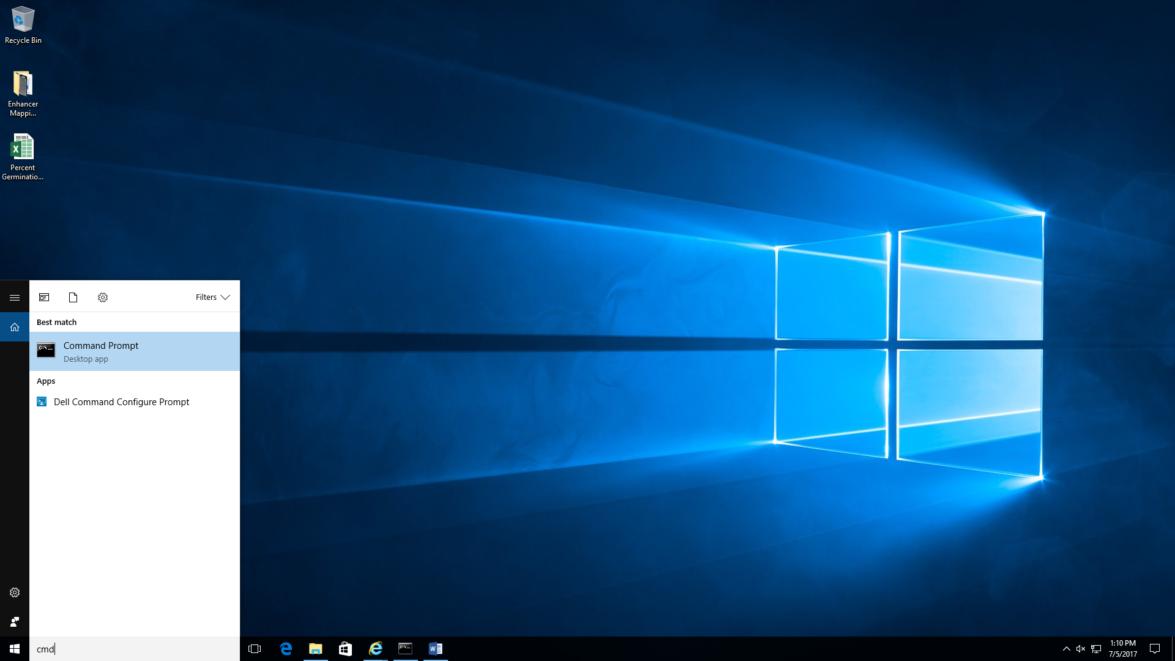

* You can change properties of the window like font size and color by right clicking the top bar of the window…

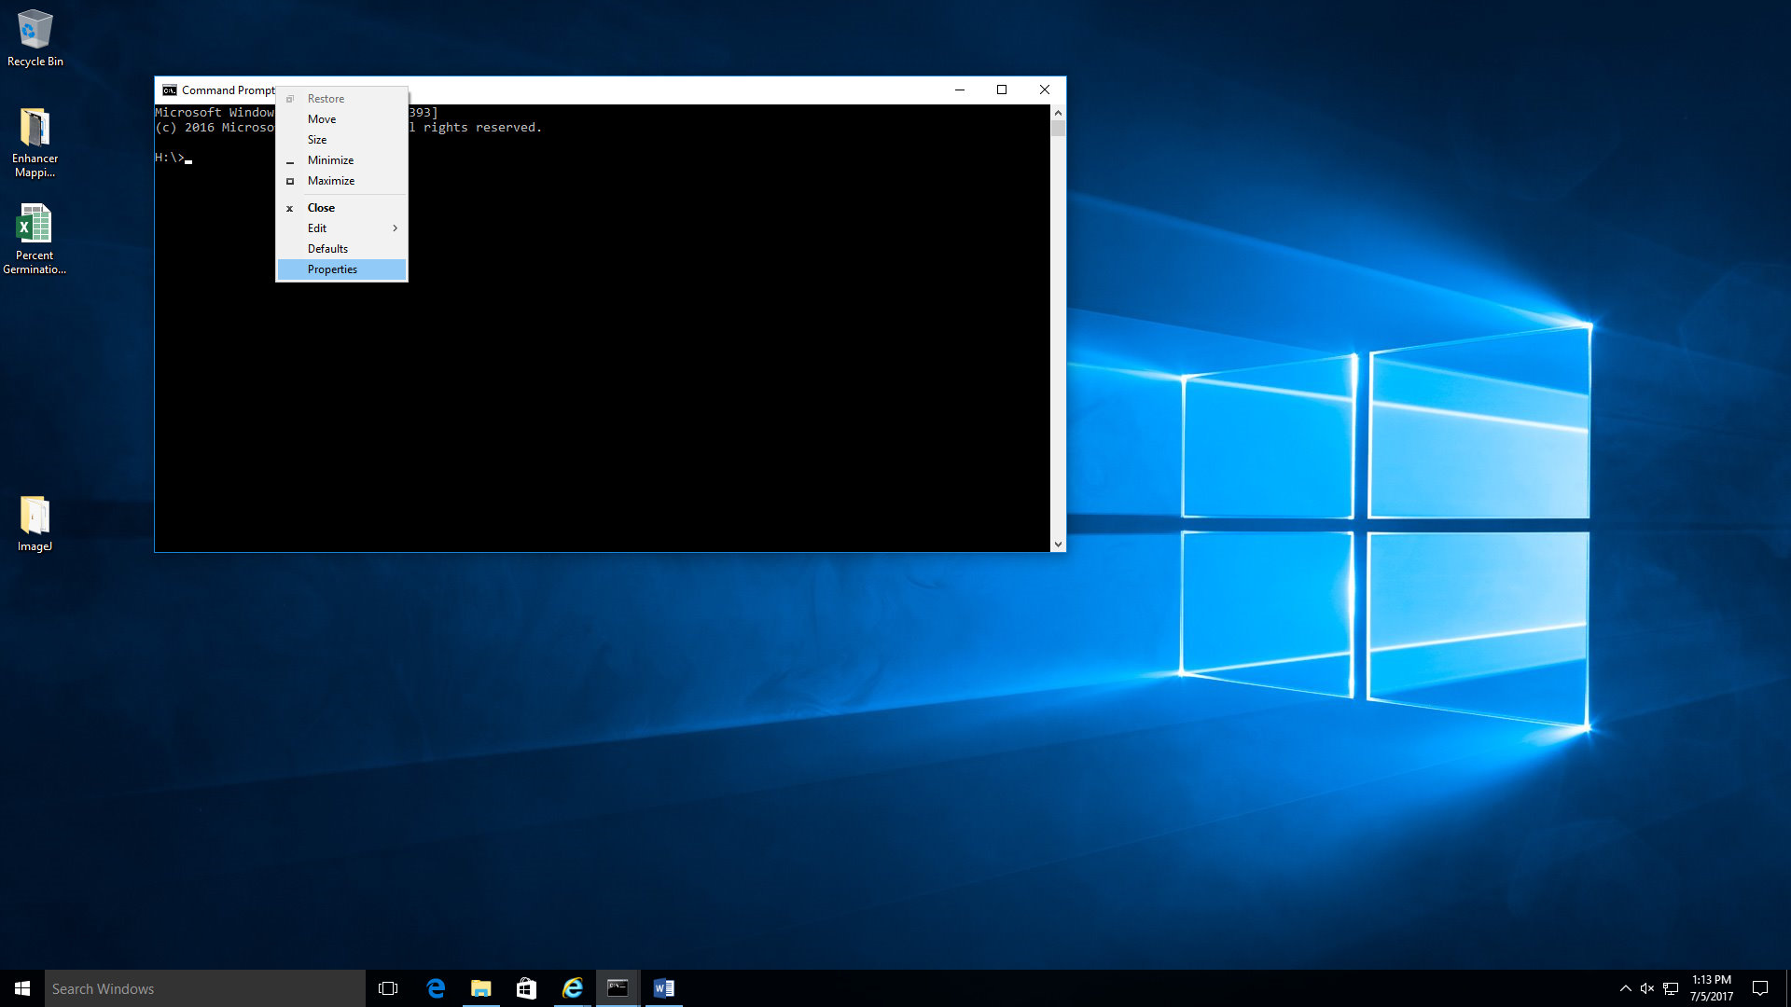

-to change to a new directory on a different drive (say you are on “H:\” and you want to get to “C:\temp”) you have to type “cd /d *directPathOrLocation*” then hit “Enter”

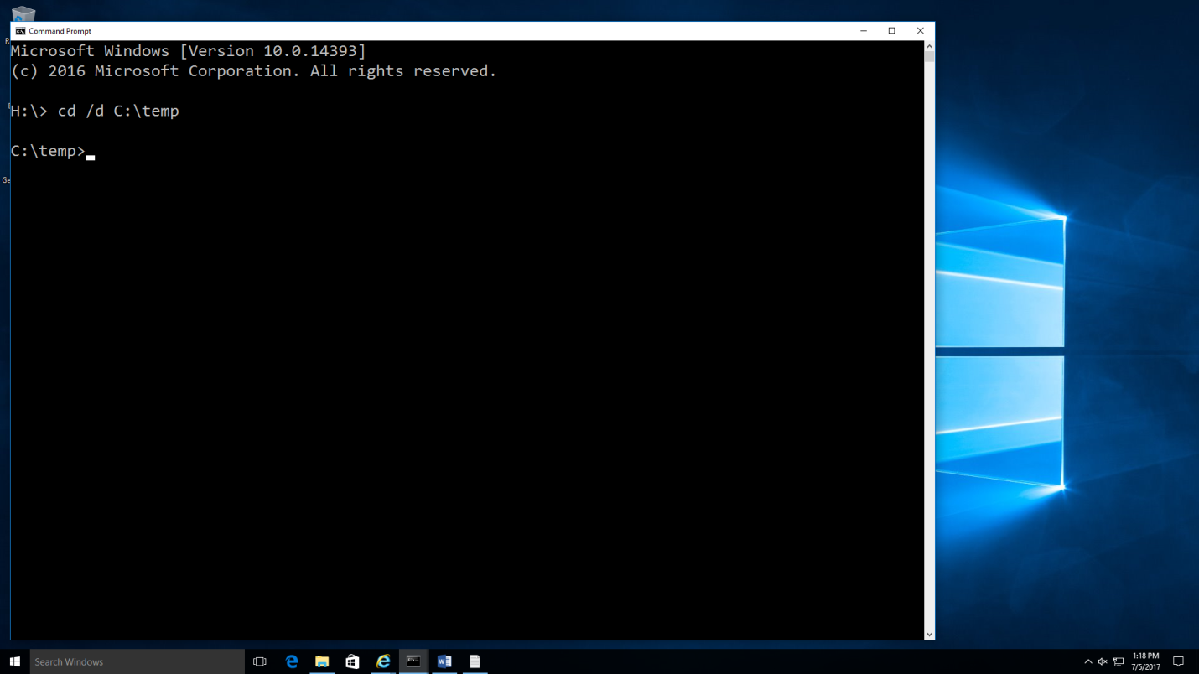

-In this case we want to work in the C:\temp folder for this example. I saved a “FASTA_batch.txt” there, but you may not have one there. File “temp” can be whatever you want it to be called. If you do not have a “FASTA_batch.txt” file in your “C:\temp” make an FASTA format text file there now saved as “FASTA_batch” (or whatever name you want). If you do not have a “temp” folder make one on your C drive as well before making the FASTA file.

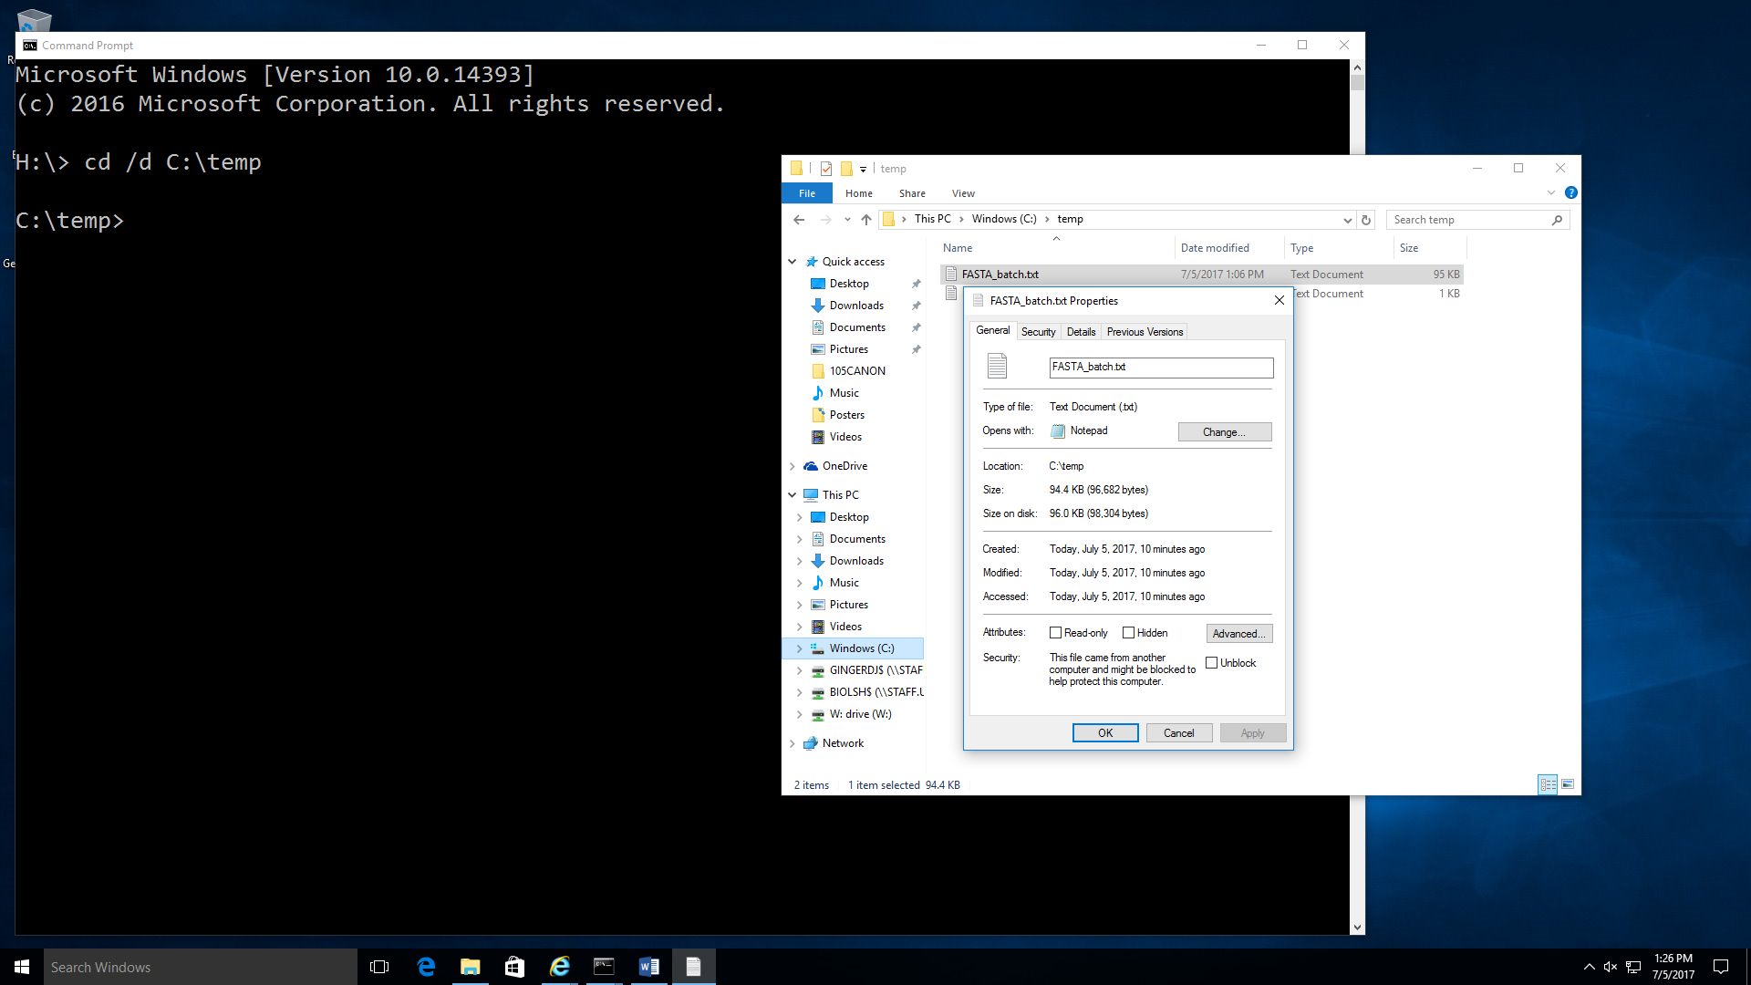

**Setting up your computer to run SMART_batch Perl script**

-Start by going to this web page… <https://www.perl.org/get.html#win32> …and download Strawberry Perl

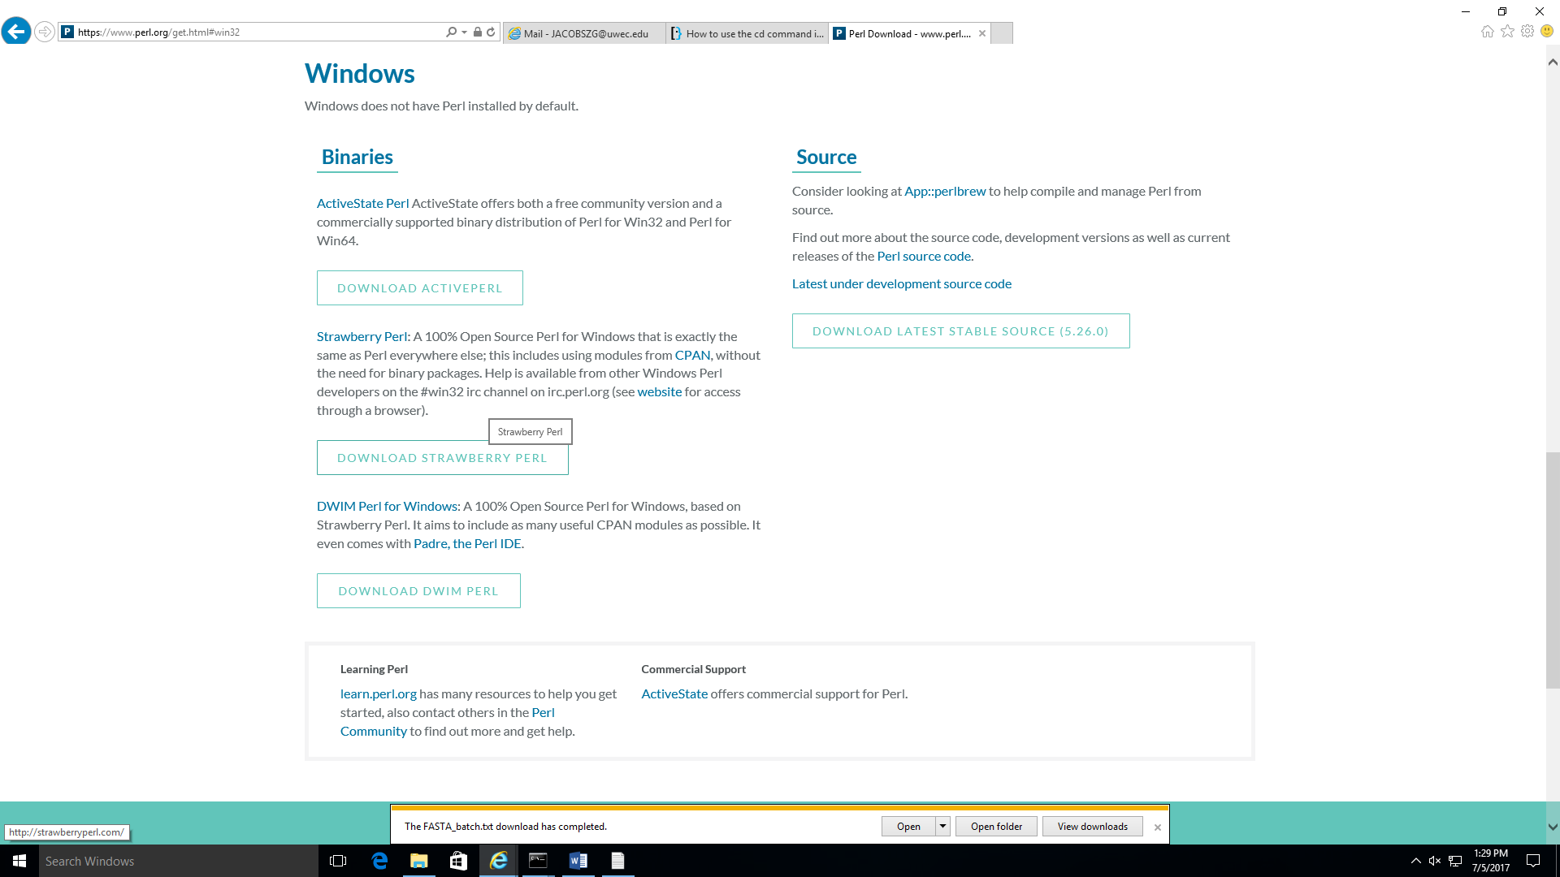

- Run the 64 bit Strawberry Perl for windows (other operating systems will need alternate appropriate download) and set it up on the computer

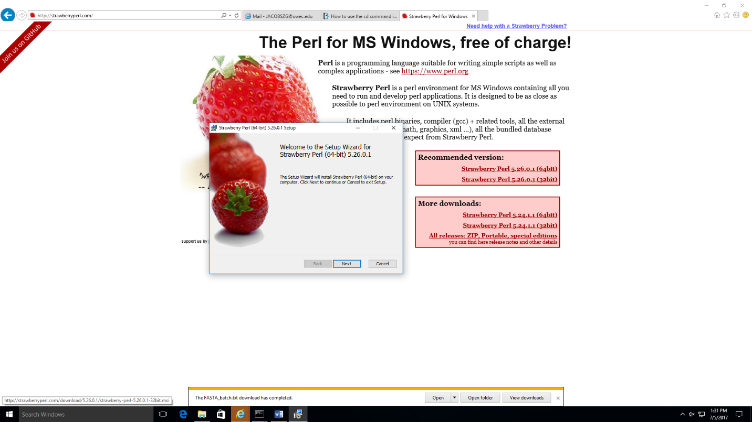

...and then run the Setup Wizard

**Getting the SMART_batch Perl script**

-To get the SMART_batch.pl file go to this web page… <http://smart.embl-heidelberg.de/help/SMART_batch.pl> and copy and paste all of the text into a text file and save as “SMART_batch.pl”. It should be seen as a “Perl program file” type in the file viewer. Save it in the /temp folder for this example

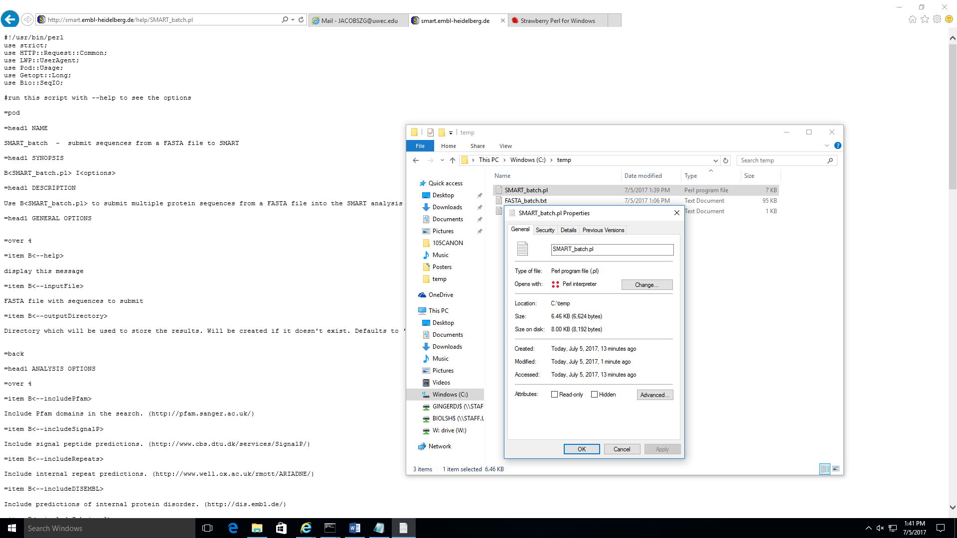

**Further “one-time” computer set-up involving the Command Prompt window**

-Next thing you will need is to patch up the POD reader (if you are using windows) by clicking the following link and saving the patch… <http://strawberryperl.com/package/kmx/perl-modules-patched/Pod-Perldoc-3.27_patched.tar.gz>

- You will now need to download the “Bio::SeqIO module” in your Command Prompt window by first opening “CPAN”… type “perl -MCPAN -e shell” and disregard the error for now if you get one… 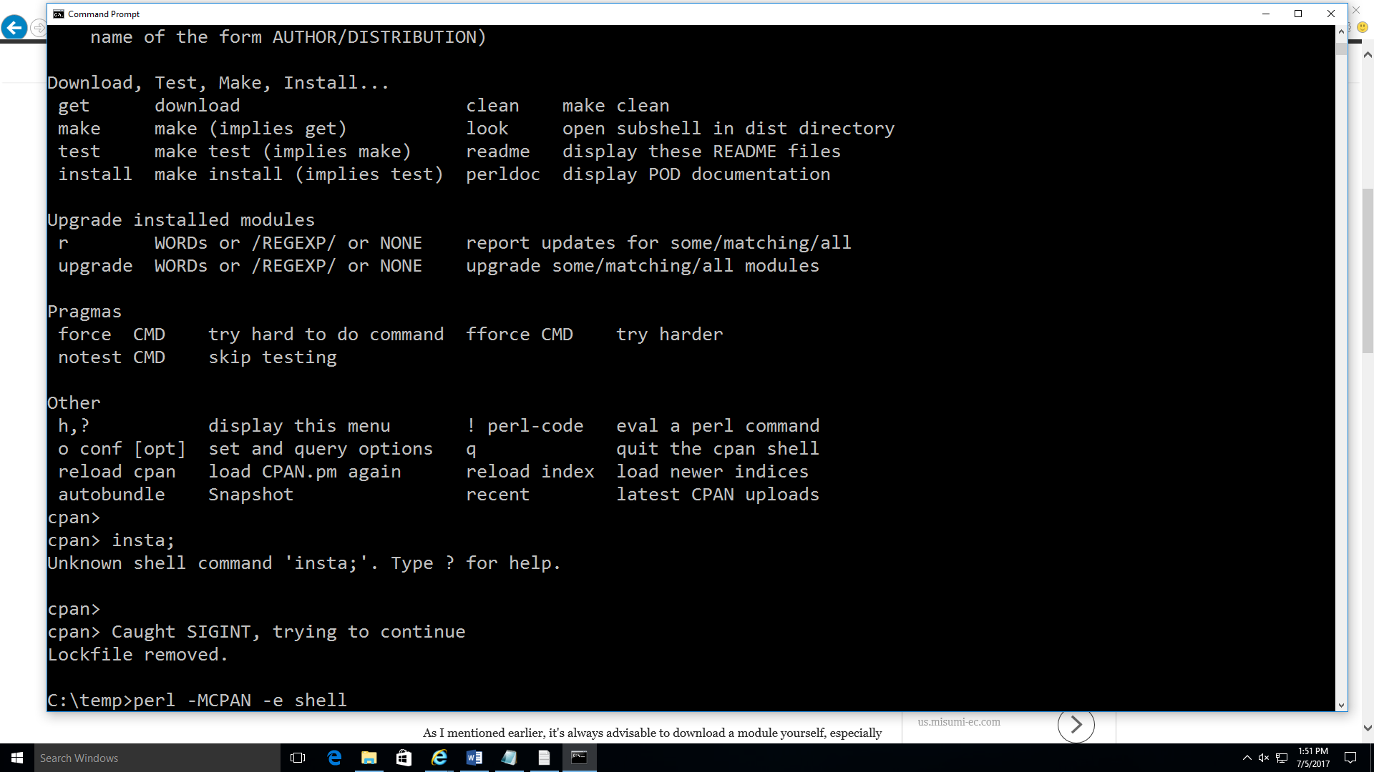

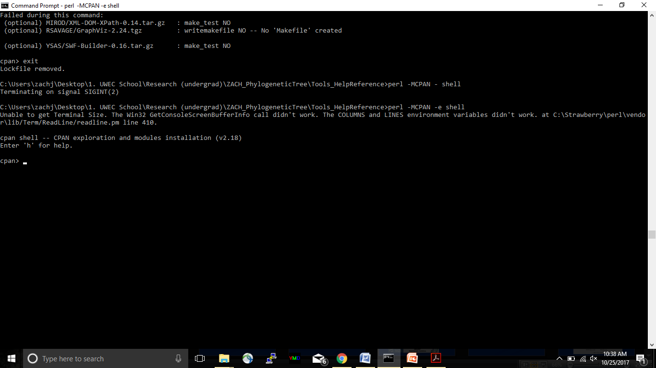-THIS WILL TAKE SOME TIME (I would wait by your computer until you answered all the questions, then go take lunch or something. Make sure your computer does not go to sleep. That may interrupt the download process.). You should now be in the CPAN environment…

…and can now install the “Bio::SeqIO module” by typing “install Bio::SeqIO module” and hit “Enter” then wait... and wait… It will ask a few questions. Answer using the default answer provided after the “?” in the brackets (example: “? [n]” or “? [a]”). You will still need to enter “n” or “a” and then hit enter to proceed. After you answer the questions you will wait some more as it does its thing… if it appears to stall longer than 2 minutes hit “Enter”

Example of what you should see scrolling down your window…

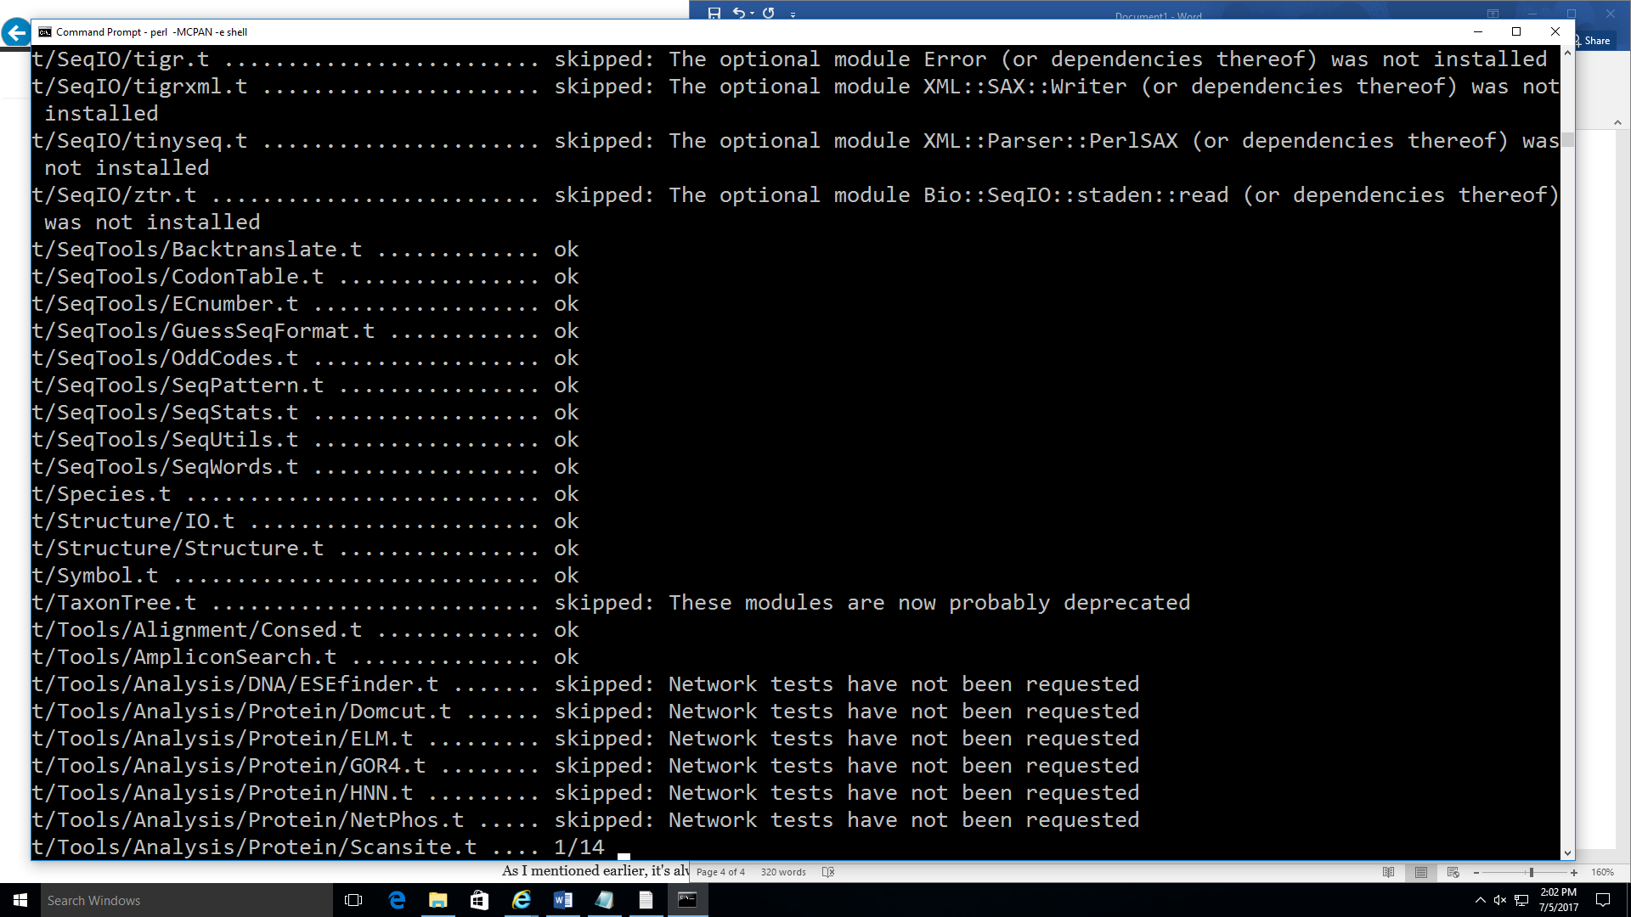

-Now you should be able to run the perl script. Close the command prompt window and re-open it changing to the C:\temp directory like before. Then type “perl SMART_batch.pl --help” into the command prompt window and hit “Enter” to test. You should get a result that looks like this…

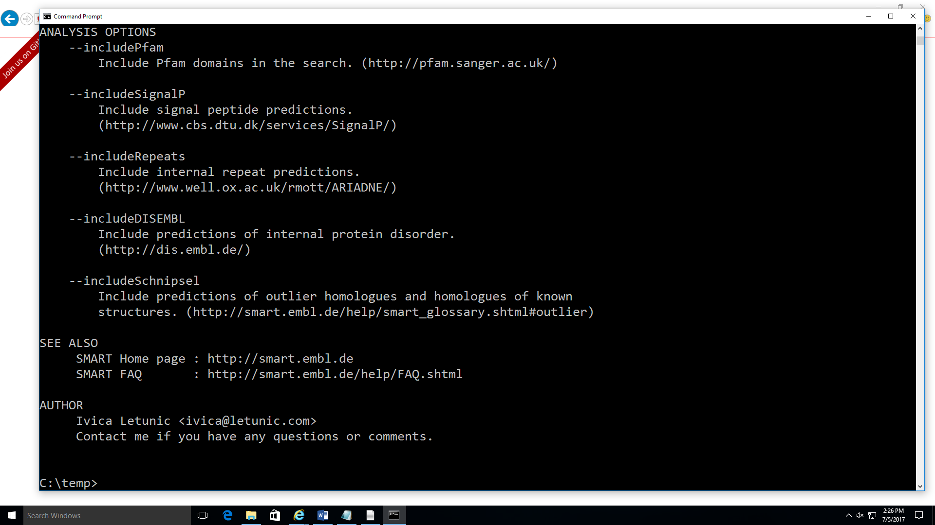

If you do not get this follow the prompts provided from your Command Window, or try the set up again.

-Follow provided help instructions that print into the Command Prompt window. For the ASPB 2017 project we typed in “perl SMART_batch.pl --inputFile FASTA_batch.txt --includePfam --includeSignalP --includeRepeats --includeDISEMBL --includeSchnipsel” and hitting “Enter” to get a running screen that looks like this…

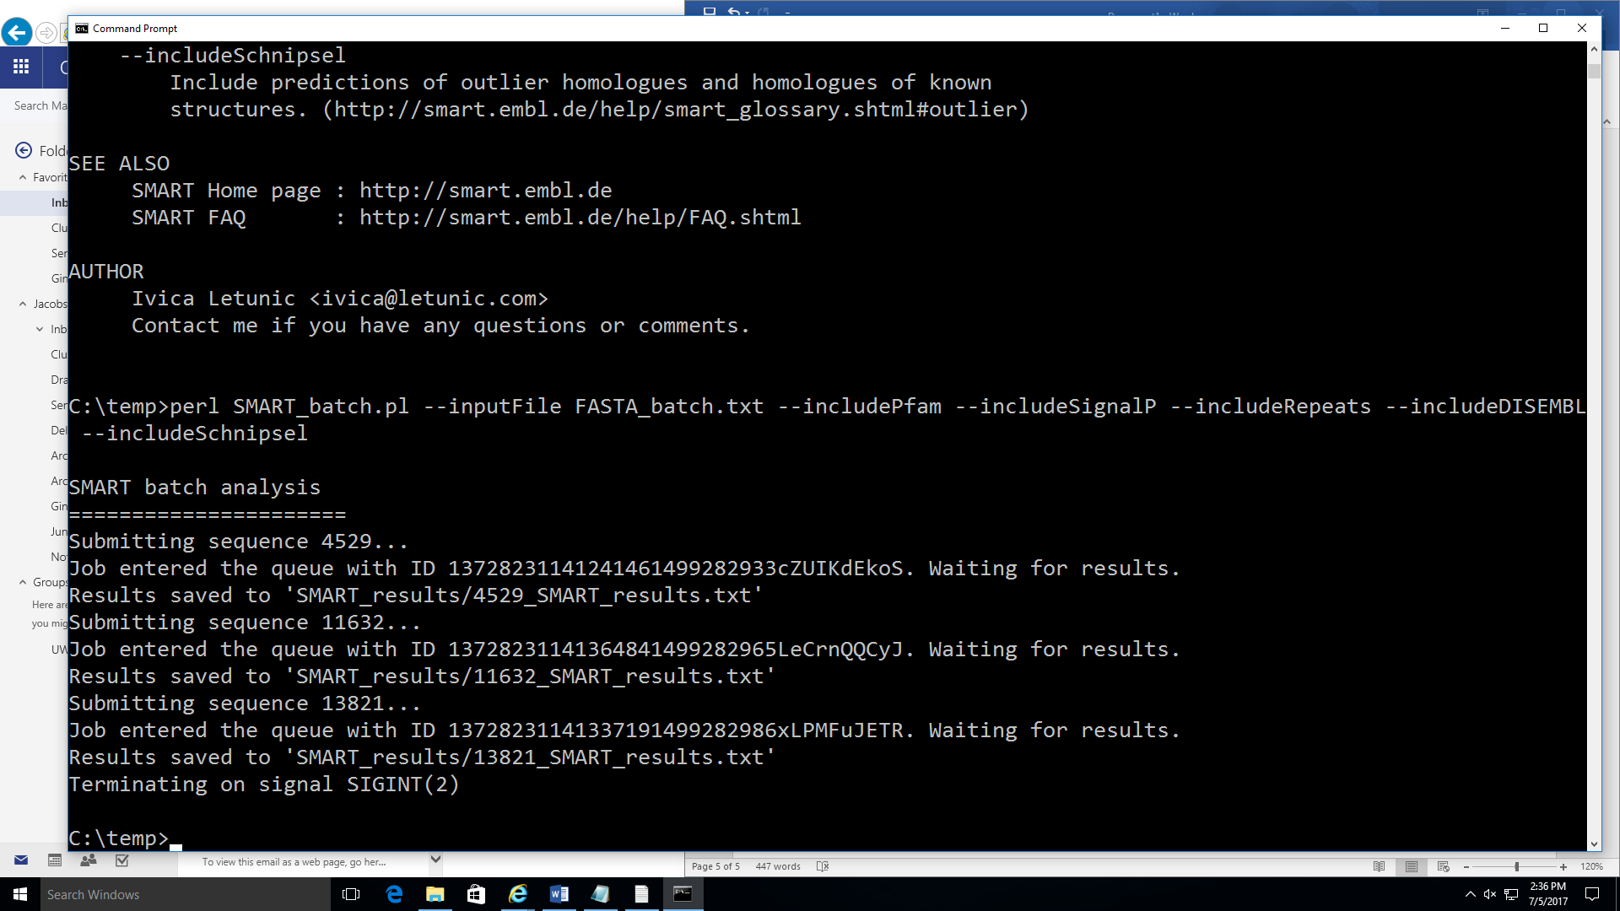

Make sure you get spacing right when you enter the command. Copy from this word doc and Pasting works too, just switch out FASTA_batch.txt with whatever .txt file you have your MASTER FASTA saved as.

-If you look in your /temp folder you should see a “SMART_results” folder that was created with text files being generated for each loci being run with the script from the “FASTA_batch.txt”

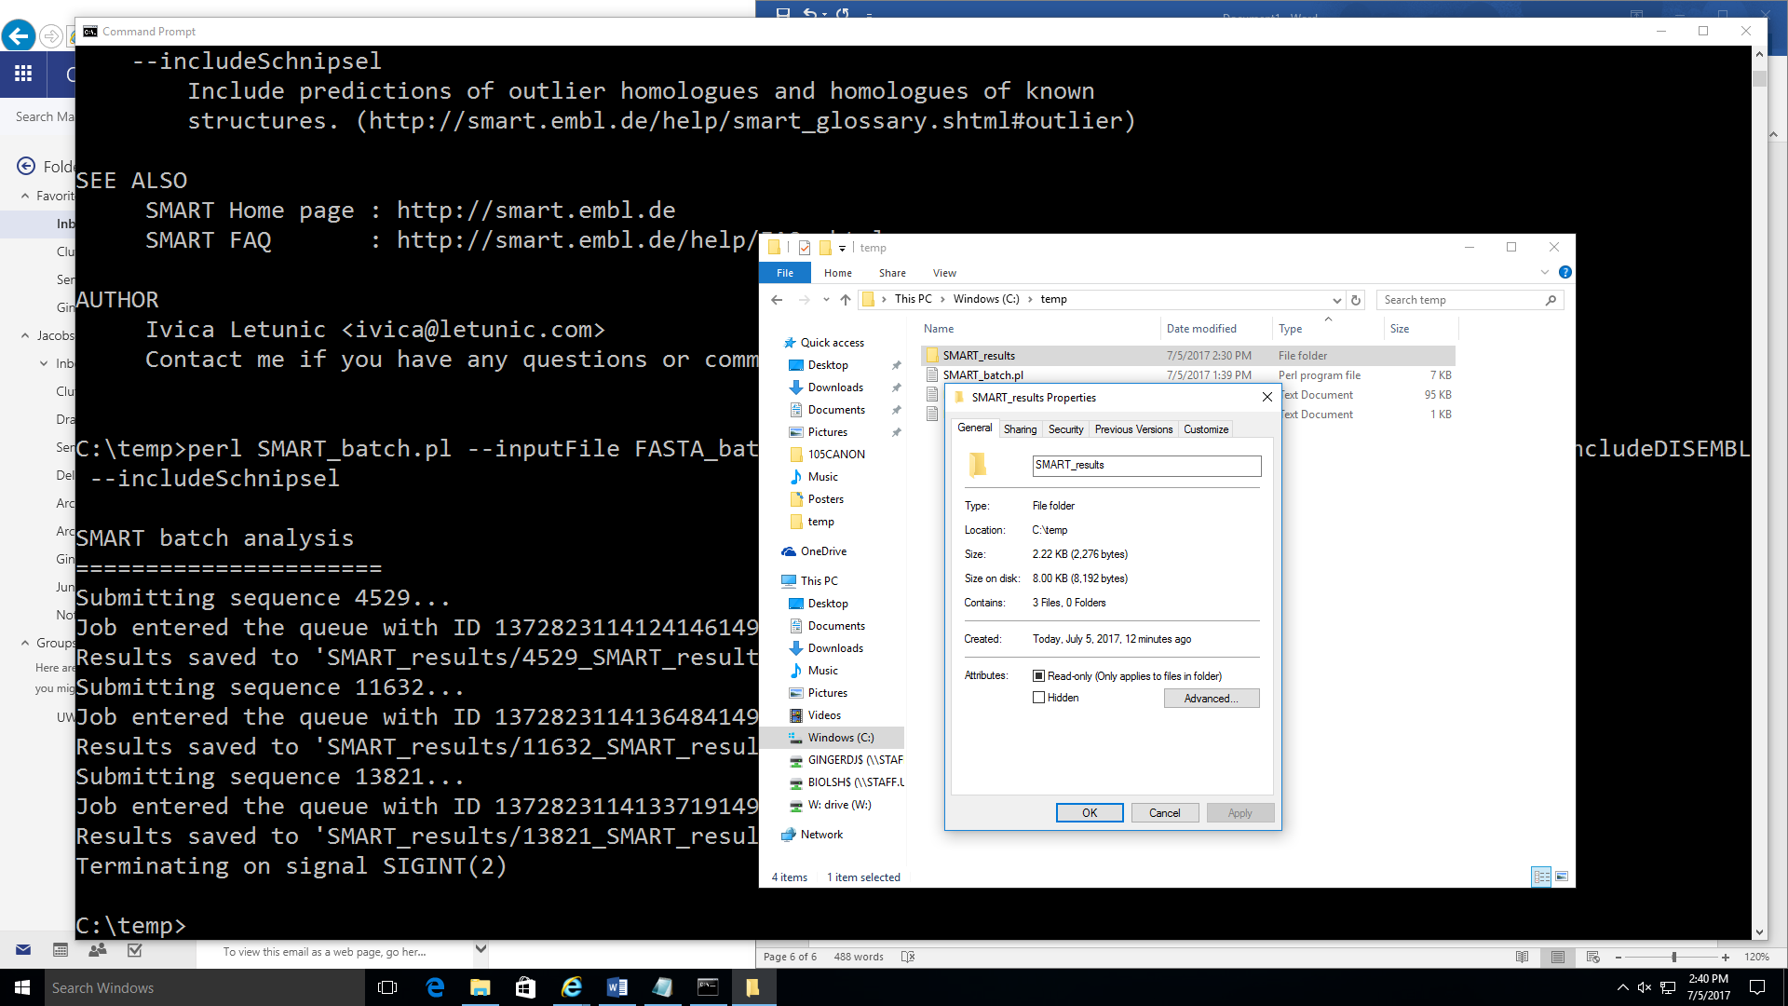

HELPFUL TIPS

-Check the SMART_results progress often as this program may crash once in a while (like once every 4-5 hours). If it does crash just start the SMART_batch.pl back up again per instructions below…

-You can cancel/stop the batch process by typing “ctrl”+”c” in the command prompt window, and pick it up again later. To close the Command Window type “exit”.

-To start it up again re-open the Command Prompt window, change your directory to the file holding the SMART_batch.pl and SMART_results folder, and then re-enter “perl SMART_batch.pl --inputFile FASTA_batch.txt --includePfam --includeSignalP --includeRepeats --includeDISEMBL --includeSchnipsel” (where FASTA_batch.txt is your own FASTA list you named) and it will pick up where it left off.

-to speed up the searches you can open the “SMART_batch.pl” and change 10 to 7 and save it. This has the potential to increase the number of crashes though. If you go lower than 7 you will begin to block the SMART servers and prevent other users from accessing SMART search result from the web…

} else {

#still in queue

sleep 10;

}

…to …

} else {

#still in queue

sleep 7;

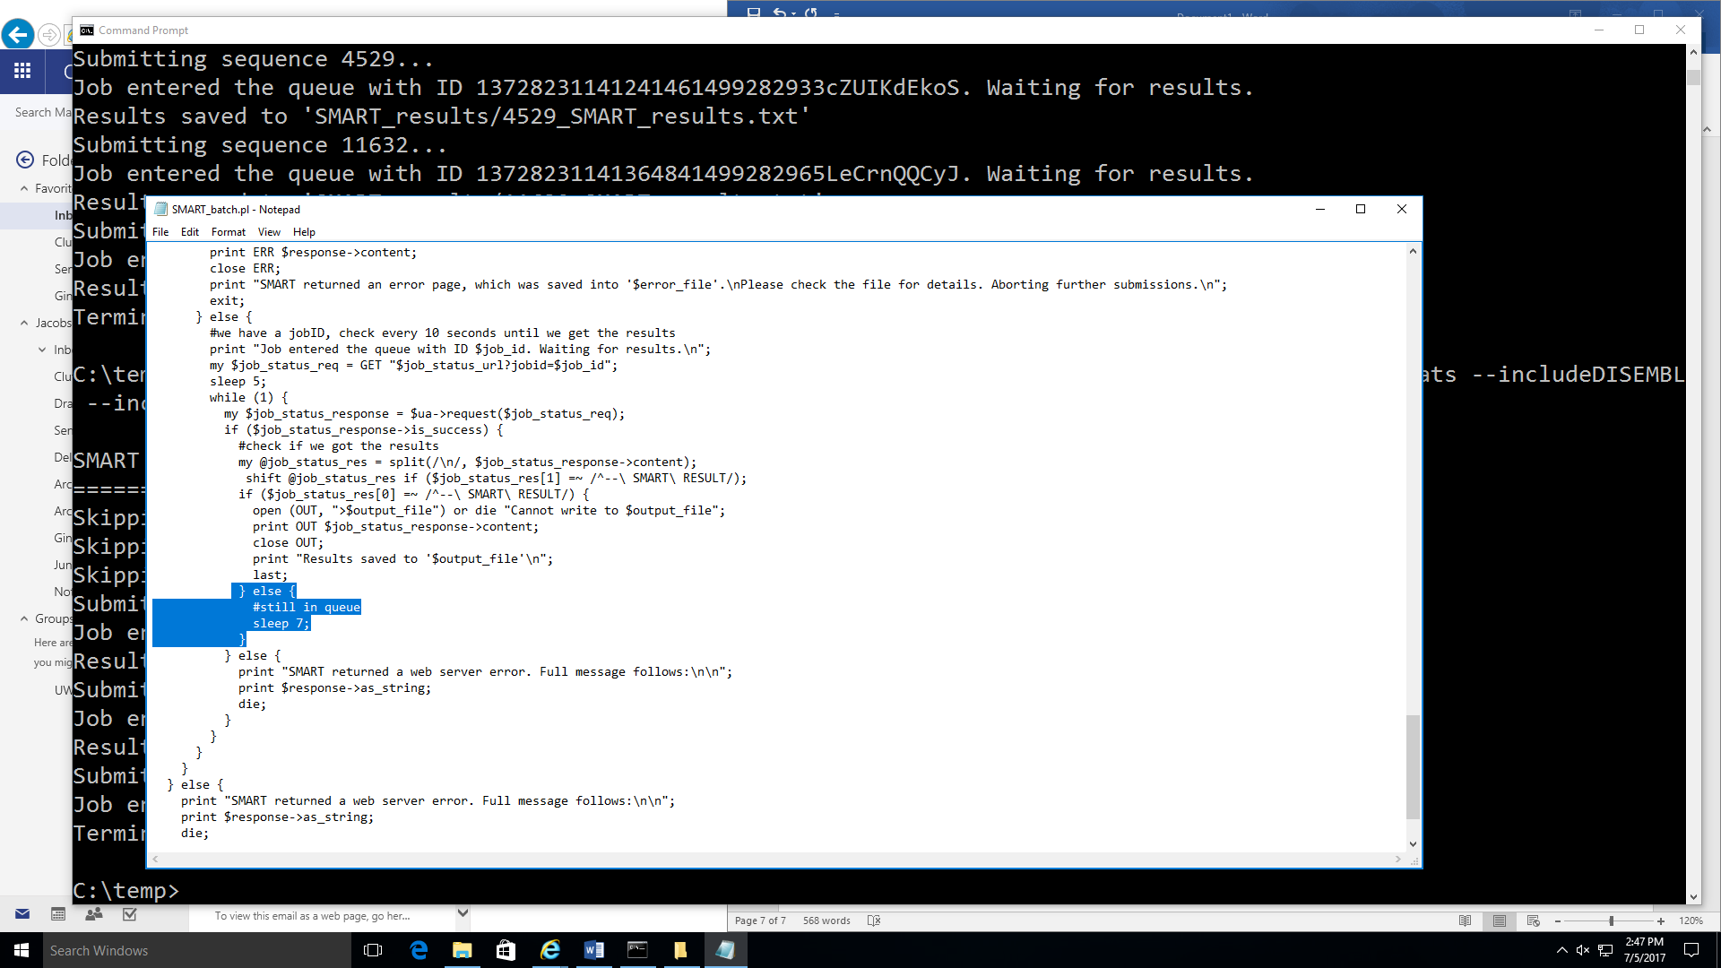 }

-If your folder holding the SMART_batch.pl and the FASTA_batch.txt (and eventually the SMART_results folder) is buried deep and nested within many folders you will still need to change your directory (cd) to that deep folder in order to run the SMART_batch.pl using these instructions. An easy way to quick change to that folder as your working directory is to right click on the SMART_batch.pl (or the FASTA_batch.txt which is in the same folder) and open “Properties”...

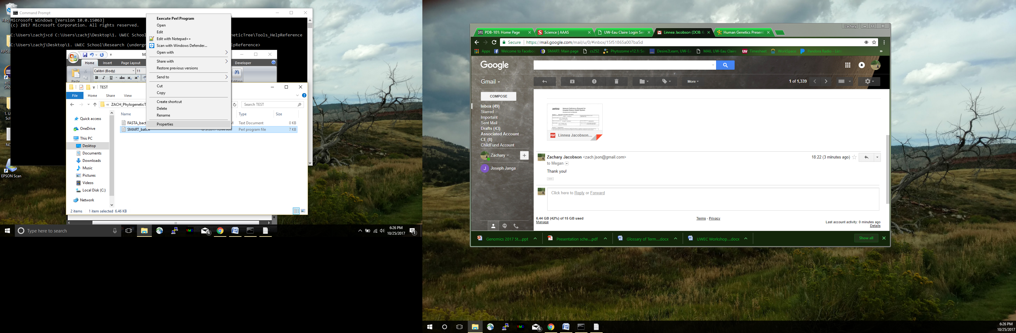

… Highlight and copy the location…

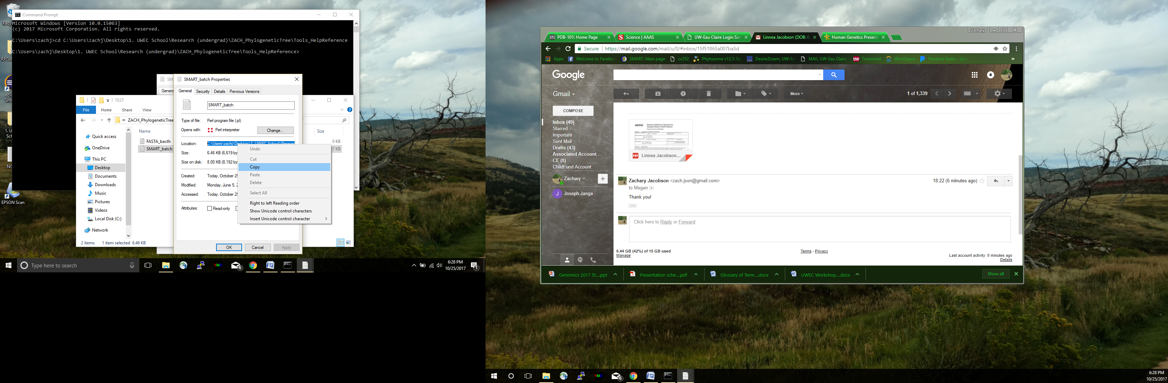

…then in the Command Prompt window type “cd” space ([ctrl]+’v’) then hit Enter. You should now be in that folder.

*FUTURE WORK: It would be very beneficial to create tables in an actual database that could be manipulated using MySQL or Oracle (talk to CS dept about using the “Dario” server?). View screen shot below.

